**CPP_Assignment_1b**

**BNK/01 The class should have following data members : Customer Name, Account Number, Type of Account (Savings/Current etc), Account Balance.**

**Ans:**

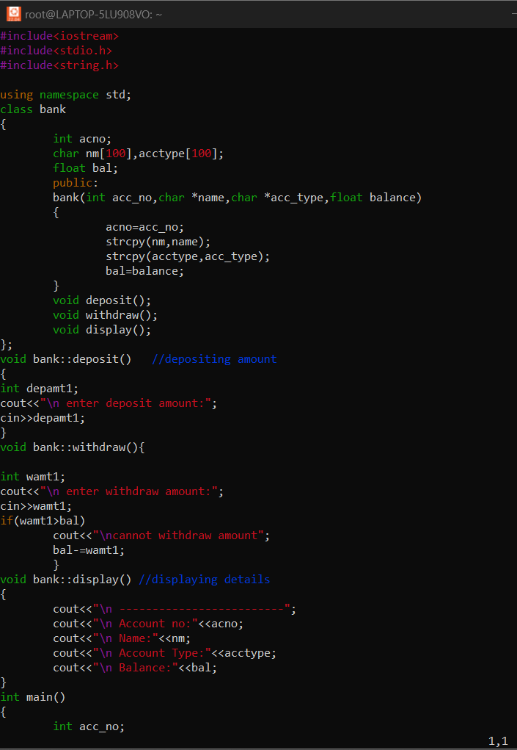

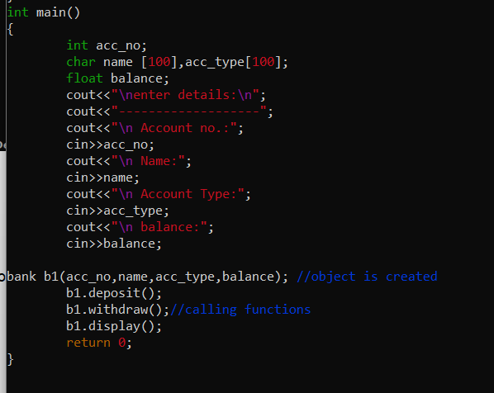

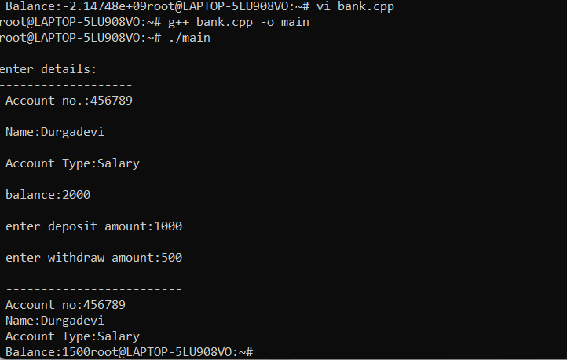

**BNK/02 The class should allow basic operations like creating a new account, deposit an amount, withdraw money after checking the balance, display account details.**

**Ans:**

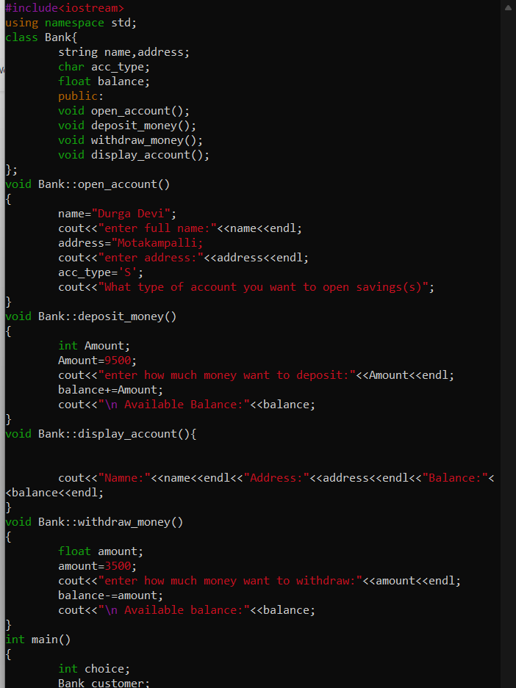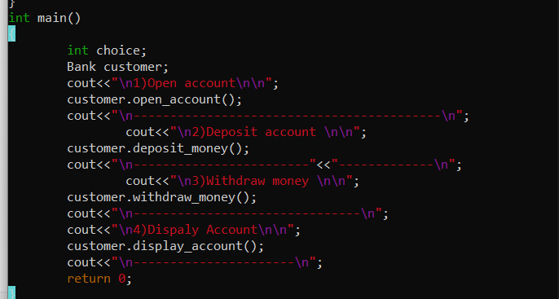

**BNK/03 Add a non member function updateName() to receive a reference to an account object and a new name string. This function should update name and return the reference object.**

**Ans:**